AgNbO₃ model electrode material (Times New Roman 14)

Olivier Crosnier^{1,2}, Camille Douard^{1,2}, Thierry Brousse^{1,2}

¹Nantes Université, CNRS, Institut des Matériaux de Nantes Jean Rouxel, Nantes, France

²RS2E, CNRS FR 3459, Amiens, France (Times New Roman 12)

1. Introduction (Times New Roman 11)
Innovative electrode materials that support fast charging is becoming a challenge for a wide range of applications ranging from Automotive Guided Vehicles to Pitch Control in wind turbines. Diverging from well-known high-rate negative electrode materials like Li₄Ti₅O₁₂ (LTO)¹, Le Calvez et al.² have suggested a new model material that can undergo fast charging with minimal stress issues. In this communication, we unveil the electrochemical mechanism underlying fast charging ability of AgNbO₃ and we emphasize the role of electrochemical window to balance high energy and high power capability.

2. Experimental
The synthesis process is schematically illustrated in Fig. 1a.
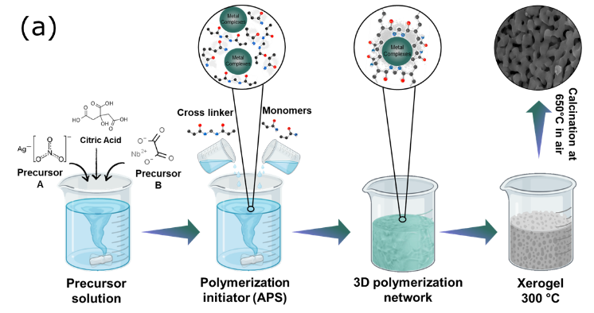
Fig. 1. (a) Schematic illustration of polyacrylamide synthesis of AgNbO₃ perovskites (from ³)
(One figure maximum)

3. Results and discussions
During 1st lithiation, a unique activation process is observed due to Ag-exsolution from A-site of structure causing A/B non-stoichiometry, which results in a compensation of Ag⁺ by Li⁺ cation intercalation. Structural transition between crystalline to amorphous oxide is observed below 0.3V vs. Li+/Li concomitantly to Nb⁵⁺ reduction. Further, Li-Ag nano (de)alloying process is observed at the end of the reduction process. Overall, AgNbO₃ delivered a specific capacity of 226 mAh.g⁻¹ in extended potential window (0.01 – 3.0V), which is thirteen-fold compared to the capacity of material in its electrochemically stable potential window (1.2 – 3.V). Furthermore, high-power capability was observed with a capacity retention of 72 mAh.g⁻¹ at 2A.g⁻¹ as well as a very good cycling stability and efficiency at 1A.g⁻¹ after 2500 cycles.

Acknowledgements: this work was carried out within the framework of HIPOHYBAT project (PEPR Batteries)

References:
(1) Prakash, A. S. et al. Chem. Mater. 2010, 22 (9), 2857–2863.
(2) Le Calvez, E. et al. Investigating the Perovskite Ag_{1-3x}La_{x}NbO₃ as a High-Rate Negative Electrode for Li-Ion Batteries. Front. Chem. 2022, 10.
(3) Khan, A. et al. Lithium storage behaviour of AgNbO₃ perovskite: Understanding electrochemical activation and charge storage mechanisms, Energy Storage Materials 70 (2024) 103431.

